**PubTrack: A WEB-BASED RESEARCH PUBLICATION MONITORING AND MANAGEMENT SYSTEM**

**BUTAWAN, BERN FRANCIS C.**

**RANA, KYLE AARON**

**JULY 2024**

**Chapter 1**

**THE PROBLEM AND ITS SCOPE**

**Introduction**

Research is a vital aspect of academic activities. Academics, students, and professionals can use research to explore unknown ideas, establish new hypotheses, and contribute to the advancement of human knowledge in a variety of domains. It promotes innovation by encouraging the creation of new technologies, methodologies, and solutions to complicated problems.

Organizations utilize monitoring and evaluation systems to measure, track, and assess project outcomes. Organizations can increase their performance, effectiveness, and project success rates by upgrading their monitoring and assessment processes. Furthermore, several studies demonstrate the importance of information and communication technology systems in monitoring and evaluation tasks (Mleke & Dida, 2020). Monitoring systems are critical components for evaluating programs and procedures, identifying strengths or weaknesses in schools, contributing to decision-making, and carrying out educational management activities at many levels, such as the school, municipal, or federal level (Komar et al., 2019).

Publishing research is an important aspect in academic reputation and career progress. Research publications are the major means of disseminating new knowledge and discoveries throughout the academic community and the general public. Researchers share their results through journals, conferences, and other forums, thereby contributing to a greater understanding of a specific field. It allows researchers to engage in intellectual discussions with their colleagues. Researchers contribute to continuing discourses in their disciplines by sharing their methodology, findings, and interpretations, shaping the trajectory of academic thinking and inquiry. High-quality research publications boost a university's visibility and reputation, attracting top faculties, researchers, and graduate students. Aspiring academics frequently select colleges known for their research quality, resulting in a positive loop that strengthens the university's academic community. It fosters a collaborative and intellectually engaging environment in which staff and students actively participate in research projects, conferences, and academic discussions.

The importance of research publication monitoring in academics cannot be overstated, as it plays a critical role in improving the efficiency, visibility, and impact of scholarly activity. Academics can gain significantly by methodically tracking and managing research publications. Effective research publication monitoring adds to increased institutional exposure and repute. Monitoring research publications is an important part of efficient academic research administration. It not only helps with individual and institutional evaluations, but it also enriches the broader research ecosystem by promoting an environment of excellence, collaboration, and strategic growth inside academic institutions.

PubTrack: A Web-Based Research Publication Monitoring and Management System supports numerous United Nations Sustainable Development Goals (SDGs). Firstly, it helps to achieve Goal 9 (Industry, Innovation, and Infrastructure) by encouraging technical innovation in research publication management, which improves the efficiency and accessibility of academic material. This promotes Goal 4 (Quality Education) by making it easier for educators, researchers, and students to access current research, which is critical for increasing knowledge and encouraging learning. Furthermore, PubTrack indirectly contributes to Goal 3 (Good Health and Well-Being) by facilitating the dissemination of medical and scientific research, which is critical for improving healthcare outcomes and boosting well-being worldwide.

PubTrack is a platform designed to streamline the monitoring and management of research publications. This comprehensive toolset includes features for data entry, efficient retrieval, and detailed reporting on all aspects of research publications. It allows researchers to submit their manuscripts directly through the platform, gaining real-time insights into the publication status at every stage of the process. It is a platform that has the ability to track each publication step. From initial manuscript submission to review, approval, and any necessary corrections.

**Framework**

Input-Output (IPO) Model provides a systematic approach to determining a system's goals and objectives as outputs, as well as how those outputs may be measured to assess process method choices. The input refers to the information that the system processes. The processing step is the set of operations and procedures performed on the input data to get the desired outcome. The output is the outcome of the processed input. This study uses the IPO (Input-Process-Output) model to identify process steps and explain the system life cycle. It helps in visualizing the complete study process, hence improving the platform's efficiency. (MacCuspie et al., 2014).

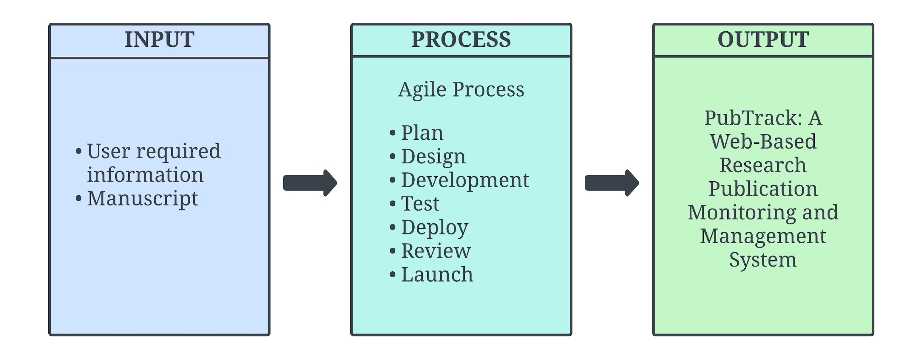

***Figure 1.*** *IPO Model of the Proposed Study*

Figure 1 illustrates how the proposed project is developed—input data such as user required information and manuscript. The developmental process will follow a thorough sequence, beginning with planning and design. Moving on to the development phase, which includes development, integration, testing, and launch. The output of the entire process is the Web-Based Research Publication Monitoring. The IPO model is ideal for PubTrack because it offers an organized, transparent, and communicative framework for comprehending and constructing an effective web-based research publication monitoring and management system. It facilitates systematic analysis, design, implementation, and testing phases essential for such a software system.

|  |  |  |
| --- | --- | --- |
| **Criteria** | **Description** | **Acceptance Test** |
| **User Registration Form** | | |
| Required Fields | The registration form includes fields for name, email address, and password. | Verify that all required fields are present and functional. |
| **Validation and Error Handling** | | |
| Password Strength | Passwords must meet minimum security criteria and provide feedback on strength. | Verify that passwords are validated for strength and feedback is provided. |
| Field Validation | Required fields must be completed correctly, with clear error messages for any issues. | Test that incomplete or incorrect fields trigger specific error messages. |
| **Confirmation and Activation** | | |
| Email Verification | Users receive an email verification link after registration. | Confirm that users receive an activation email and the link works. |

***Figure 2.*** *User Acceptance Criteria*

**Statement of the Problem**

This study aims to develop a project that assists the research publication office in efficiently managing researchers' manuscripts and journals and updating its publication status. The study seeks responses to the following issues:

* Reliance on manual processes for manuscript tracking;
* Reliance on third party website for application forms resulting in redirecting to another website for data retrieval of manuscript applications, and
* Difficulties in updating the researchers of the status of their manuscripts.

**Objectives of the Study**

This study generally aimed to create a research monitoring website to keep track of manuscripts, it sought to:

* To develop a website that would track and monitor a manuscript;
* To create a form within the website to store the data in the database; and
* To create a notification feature to notify the researchers of their manuscript status.

**Scope and Delimitations**

The study will primarily focus on developing a web-based platform for monitoring and managing research publications, which will include tools for data entry, retrieval, and reporting on research publications. Users of this system will include the Office of the University Research and Coordination, researchers, and peer reviewers. The web-based platform will incorporate email notifications to ensure efficient communication among users. While the platform will enhance various aspects of publication management, it will not include a plagiarism checker as part of its functionalities.

The standard review process for publications will involve a minimum of two peer reviewers to ensure comprehensive evaluation and feedback. The number of revisions allowed before a paper may be finally rejected will depend on the submission deadline, providing flexibility to accommodate different research timelines. Additionally, the platform will feature reporting tools focused on tracking the number of viewers for published journals, offering valuable insights into the reach of each publication. This will help researchers and the Office of University Research and Coordination to assess the visibility and engagement of their research outputs.

To protect the rights of authors, the platform will incorporate Non-Disclosure Agreements (NDAs) for all parties involved in the review process. NDAs will be used to ensure that the content of research submissions and peer review comments remain confidential, thereby safeguarding intellectual property and maintaining the integrity of the review process.

**Significance of the Study**

The results of this study can be beneficial to the following:

**Research Departments.** The website provides a reliable way to keep track of pending publication of studies for the university to monitor researchers' manuscripts.

**Research Publication Offices**. The website provides a feature for the RPO to process approvals for manuscripts, keeping track of manuscripts that are approved and corrected to be sent back to the researcher, making it more efficient to process publications.

**Peer Reviewers.** The peer reviewers are able to review the manuscripts to be corrected and inform the RPO for the manuscript to be approved or is corrected.

**Researchers.** This website provides monitoring of the manuscripts, to see the pending publications, allowing to monitor the researchers status and receive updates from the RPO.

**Future Researchers.** This study provides valuable information and opportunities to future researchers that will help them explore various aspects of the website.

**Output of the Study**

The Web-Based Research Publication Monitoring System provides researchers with an easy and user-friendly interface for effortlessly submitting manuscripts, equipped with a real-time progress tracking dashboard. A dynamic and interactive dashboard gives researchers real-time updates on the status of their submitted publications. Users may easily check the status, and view feedback from the initial submission through peer review, and revisions.

**Definition of Terms**

**Journals** - a scientific publication that includes articles authored by researchers, professors, and other specialists. Journals concentrate on a certain discipline or field of study.

**Manuscript** - a handwritten book, document, or piece of music as opposed to a typed or printed one.

**Peer Review** - the process of someone reading, checking, and providing feedback on anything produced by another scientist or expert working in the same subject area, or a piece of work in which this is done: All of these publications have been published following peer review.

**Publication** - the creation and publication of a book, journal, piece of music, or other material intended for public sale.

**Research** - the careful examination and analysis of information and sources in order to establish facts and draw new findings.

**Researcher** - a person who conducts academic or scientific research.

**Chapter 2**

**REVIEW OF RELATED LITERATURE**

**Publication Management Systems**

As stated by Kaur (2013), publications make scientific material public and allow the rest of the academic community to assess the research's quality. Scholarly journals, professional or trade publications, and popular and general interest magazines are among the numerous sorts of publications. Scientific publications have a distinct character, position, and necessity. Academic publications have a peer review mechanism that ensures uniqueness, applicability, and growth in a certain field of study. There is a rapid online publication procedure that increases publication frequency while decreasing in-process time cost. The number of publications has been one of the performance evaluation values for higher education academics. Over the years, the obligation to publish has expanded to include not only getting published, but also getting published in a high-quality journal, with the quality ranking determined by publication categories (Rahim et al. 2013).

Organizations utilize monitoring and evaluation systems to measure, track, and assess project outcomes. Organizations can increase their performance, effectiveness, and project success rates by upgrading their monitoring and assessment processes. Furthermore, several studies demonstrate the importance of information and communication technology systems in monitoring and evaluation tasks (Mleke & Dida, 2020). Monitoring systems are critical components for evaluating programs and procedures, identifying strengths or weaknesses in schools, contributing to decision-making, and carrying out educational management activities at many levels, such as the school, municipal, or federal level (Komar et al., 2019).

According to Podalyanchuk (2020), the university's research activity includes numerous characteristics, including a relatively significant number of study areas, a range of methods for publishing scientific results, and the involvement of a large number of staff and even students in the research process. It is understandable that evaluating this process and its outcomes is a challenging assignment at the global and national levels, as well as at the industrial and academic levels. Numerous mechanisms for monitoring research activities have been devised and implemented at the national level. However, such systems are primarily concerned with the institution as a whole or are intended to solve specific tasks, such as selecting research projects, setting funding levels, and so on.

Evaluating research is made harder by the different methods and fields in academic research (Ford, 2023). National systems for tracking research often focus more on how institutions perform rather than on individual contributions, which can hide the real impact of research (Ford, 2023). To tackle these issues, new peer review models, like open peer review, have been suggested as a way to make the publishing process more transparent and accountable (Jackson et al., 2021). Ford (2023) explains the features and benefits of open peer review, showing that it might fix some problems of traditional peer review systems (Jackson et al., 2021).

Deta et al. (2022) look into how postgraduate students view and handle the challenges of scientific publishing as a requirement for graduation. Their study shows that having institutional support, like publication help services, is essential for guiding students through the difficulties of academic publishing. This highlights the importance of PMS in offering the resources and support needed for new researchers.

**Research Publication Life Cycle**

Researchers must monitor information and stay current on research trends. However, as the volume of information and techniques for remaining current increase, researchers find it difficult to consistently monitor and filter scholarly papers. This is especially true for researchers in complicated multidisciplinary disciplines (Vera et al., 2020). According to Podalyanchuk (2020), research is a vital component of academic activities. Evaluating research initiatives requires consideration of both scientific and practical aspects. Currently, research evaluation is largely used to analyze a university's overall activities or to address specific objectives, such as financing research initiatives. Leading universities are typically recognized for their excellence in research. Furthermore, they may boast of highly competent academic personnel. High research and publication outputs are associated with greater effectiveness as educators. Since universities that strongly engage in research are regarded as superior in important ways to those with lower research outputs, increasing research efficiency is the matter of improving university image, which means better opportunities to attract and retain highly qualified academic staff, facilitate admission, and increase the value of the institution's services.

**Peer Review**

Peer review is defined as the practice of putting an author's scholarly work, research, or ideas to scrutiny by others who are experts in the same field. Its purpose is to encourage authors to fulfill the established high standards of their discipline and to manage the dissemination of research data so that unfounded claims, undesirable interpretations, or personal opinions are not published without previous expert evaluation (Kelly et al., 2014). Peer review has emerged as a critical component of the academic writing process in scientific circles. It helps to ensure that publications published in scientific journals address important research issues and make reliable findings based on well-executed experiments. Submission of low-quality publications has become more common, and peer review serves as a filter to keep bad work from reaching the scientific community. The primary benefit of a peer review process is that peer-reviewed articles are a reliable form of scientific communication. Because scientific information accumulates and expands on itself, trust is very vital.

Publications serve an important role in spreading scientific information and assessing research quality. The increasing emphasis on high-quality journals highlights the importance of publication categories in assessing academic performance. Peer review, an important step in the academic writing process, ensures the credibility of scientific communication by adhering to established criteria and limiting the dissemination of spurious claims.

Monitoring and evaluation systems are critical for organizations seeking to monitor project outcomes and improve performance. Information and communication technology systems play an important part in these activities. The evaluation of research activities in universities is difficult due to the wide range of study fields, publishing techniques, and participation of various professionals and students. National-level processes exist, but they frequently focus on the institution as a whole or on specific duties like project selection and budget allocation. Overall, effective monitoring and assessment processes improve organizational success and decision-making at all levels.

**Chapter 3**

**MATERIALS AND METHODS**

This chapter presents the sequential procedures for developing and designing the Research Publication Monitoring Website. It also presents the methods and procedures in gathering all the necessary information used in the study.

**Research Design**

Agile software development life cycle is a series of stages and practices that a system goes through. Designed as a guide of the development of software in a flexible manner. The Agile methodology originally developed for software development projects because of its iterative and incremental approach (Brush, 2022).

The Agile Software Development Life Cycle will serve as a reliable framework of the project PubTrack: A Web-Based Research Publication Monitoring and Management System due to its capacity to accommodate change and the necessity for quicker software development. It enables the platform to modify requirements depending on client feedback and continuous testing.

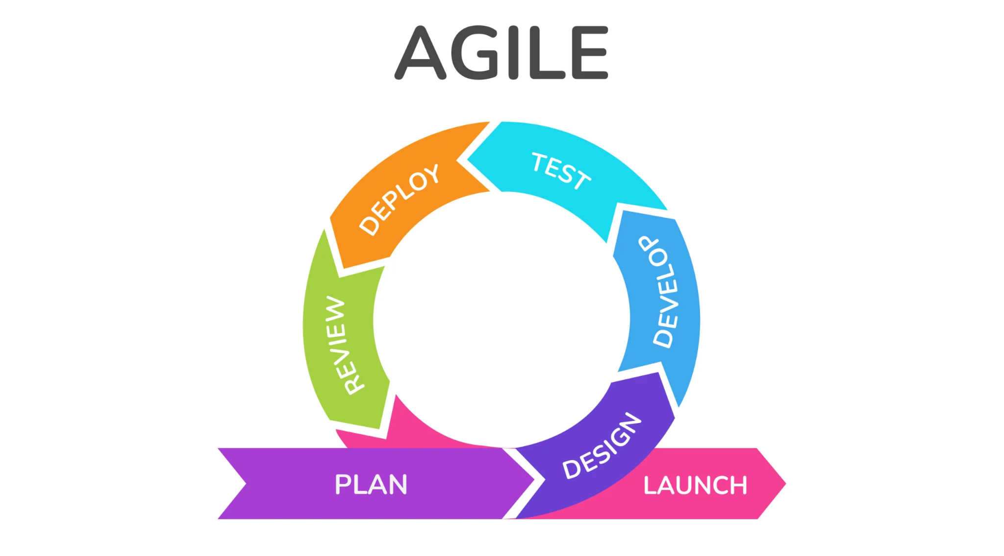

***Figure 3.*** *Agile Software Development Life Cycle Model*

The methodology selected for the study is the Agile Methodology. Initially, the researchers will gather the necessary information, incorporating insights obtained from the conducted interviews. Subsequently, the researchers will formulate a plan for the project design followed by the development process. After the development phase, a testing phase will ensue, during which the researchers will thoroughly assess the application. Deployment and review will follow the testing phase.

**Research Setting**

The study will be conducted at Liceo de Cagayan University OURC (Office of the University Research and Coordination), a setting carefully chosen for its direct relevance to the study objectives and the ready availability of participants. Liceo de Cagayan University ZOURC provides an ideal environment for implementing and testing the Web-Based Research Publication and Monitoring, as it represents a typical educational institution facing challenges in manual manuscript monitoring. The selection of this setting ensures that the study's outcomes and insights will be directly applicable and beneficial to the academic community, contributing to the improvement of Research Monitoring in educational contexts.

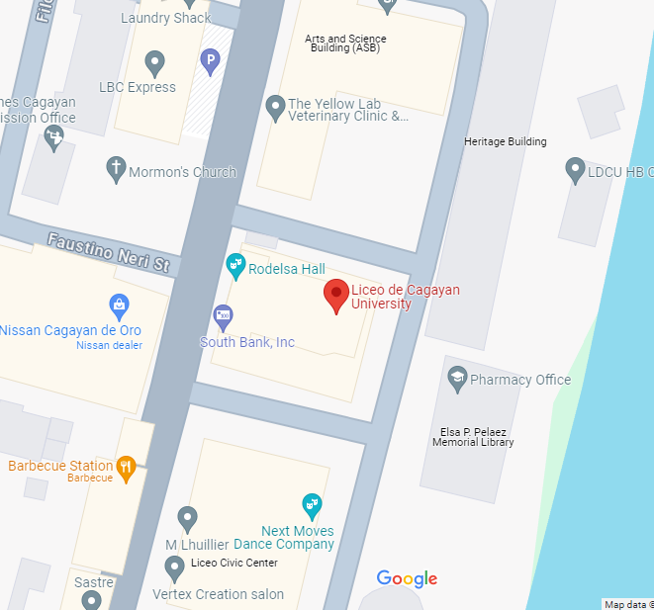

***Figure 4.*** *Location of Liceo de Cagayan University*



***Figure 5.*** *Location of Liceo de Cagayan University*

**Research Instruments**

In this study, the researchers acquired the necessary information from review of related literature and naturalistic observation of the current process of research publication monitoring. The researchers used the said research instruments as their reference materials to seek answers and understand the gaps in the study.

**Data Gathering**

For the Research Publication Monitoring Website, a comprehensive data gathering process was undertaken through structured interviews with key stakeholders. The researchers engaged with faculty members and OURC to solicit valuable insights into their specific needs, preferences, and expectations regarding the Web-based Research Publication Monitoring. The interviews were carefully designed to cover a spectrum of topics, including user requirements, desired features, and potential challenges.

**System Design**

**Current System**

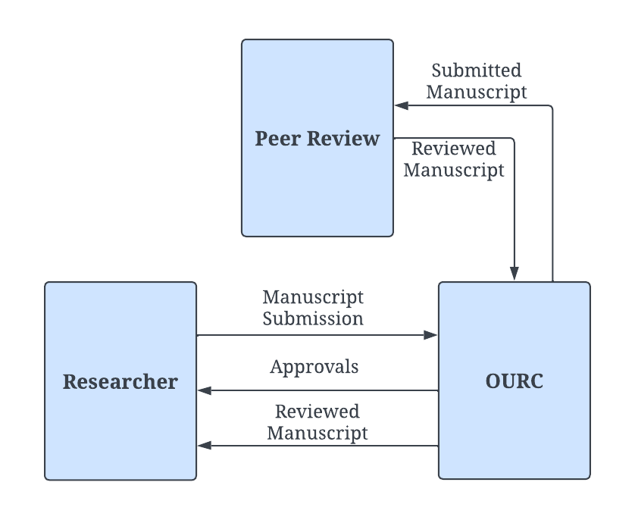

***Figure 6.*** *Diagram of the current system flow*

**Narrative description**

This figure shows the current process of submitting research papers and manuscripts to the Office of the University Research and Coordination for publication requests. The researcher will send the manuscripts to the Research Publication Office, and the office will notify the researcher when they are received. The manuscript will subsequently be sent to peer reviewers for review, who will return it to the Research Publication Office with any necessary comments and suggestions. The Research Publication Office will send the reviewed papers to the researcher for modifications, and once revised, they will return it to the Research Publication Office.

**Comparative Matrix**

A comparison matrix visualizes the similarities and contrasts between products and services, as well as more complex and abstract concepts such as strategies and ideas (Vizzlo, 2024).

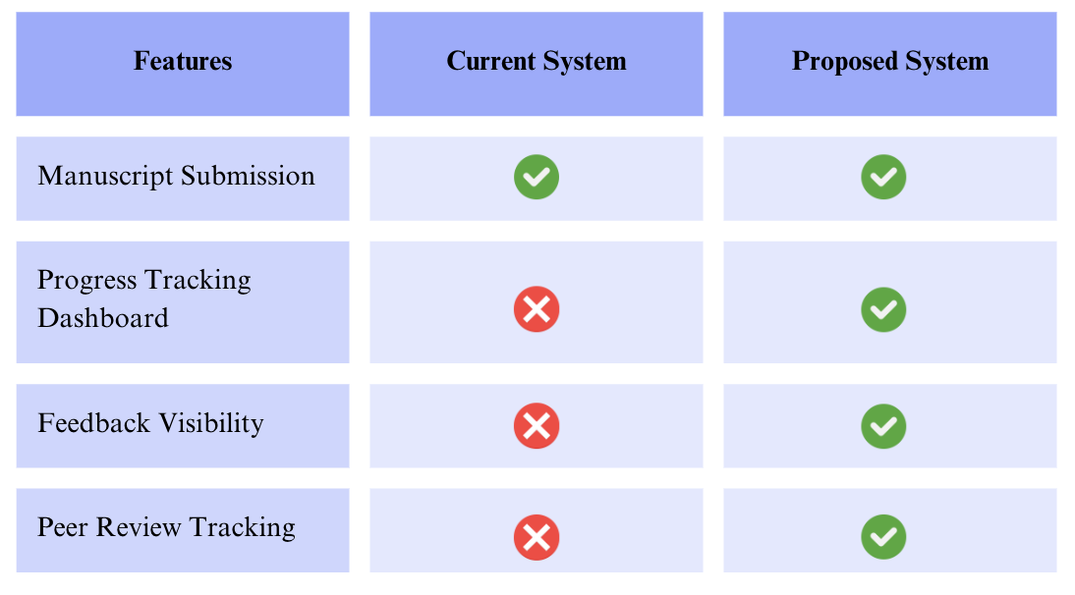

***Figure 7.*** *Comparison of the current and proposed system*

**Current System Process Flow**

**Manuscript Submission**

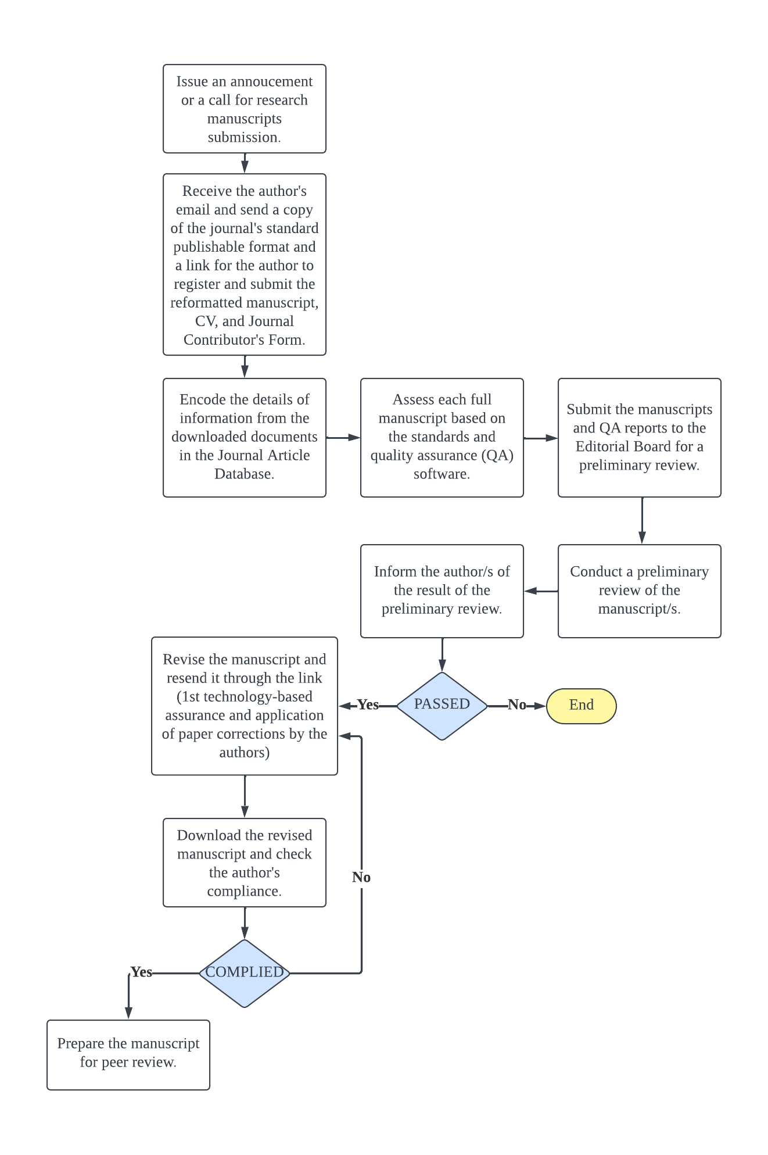

***Figure 8.*** *Current process flow for manuscript submission*

**Peer Review**

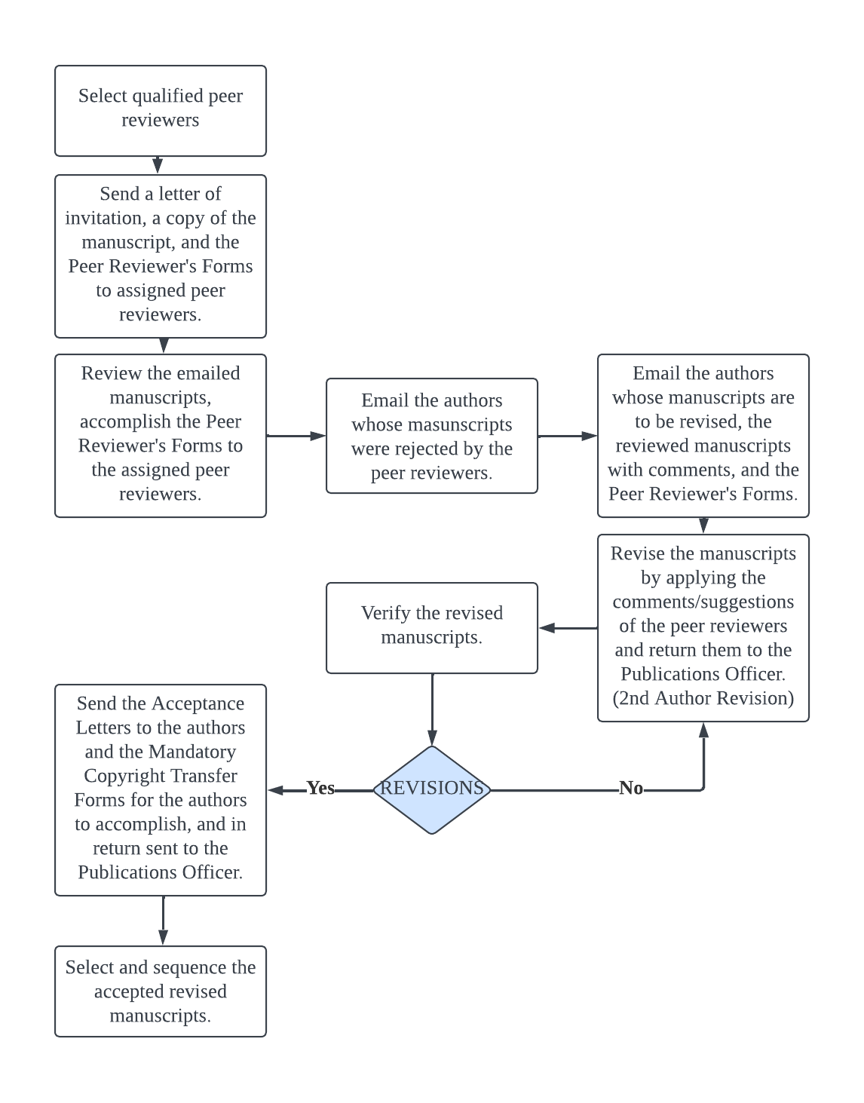

***Figure 9.*** *Current process flow for peer review*

**Proposed System**

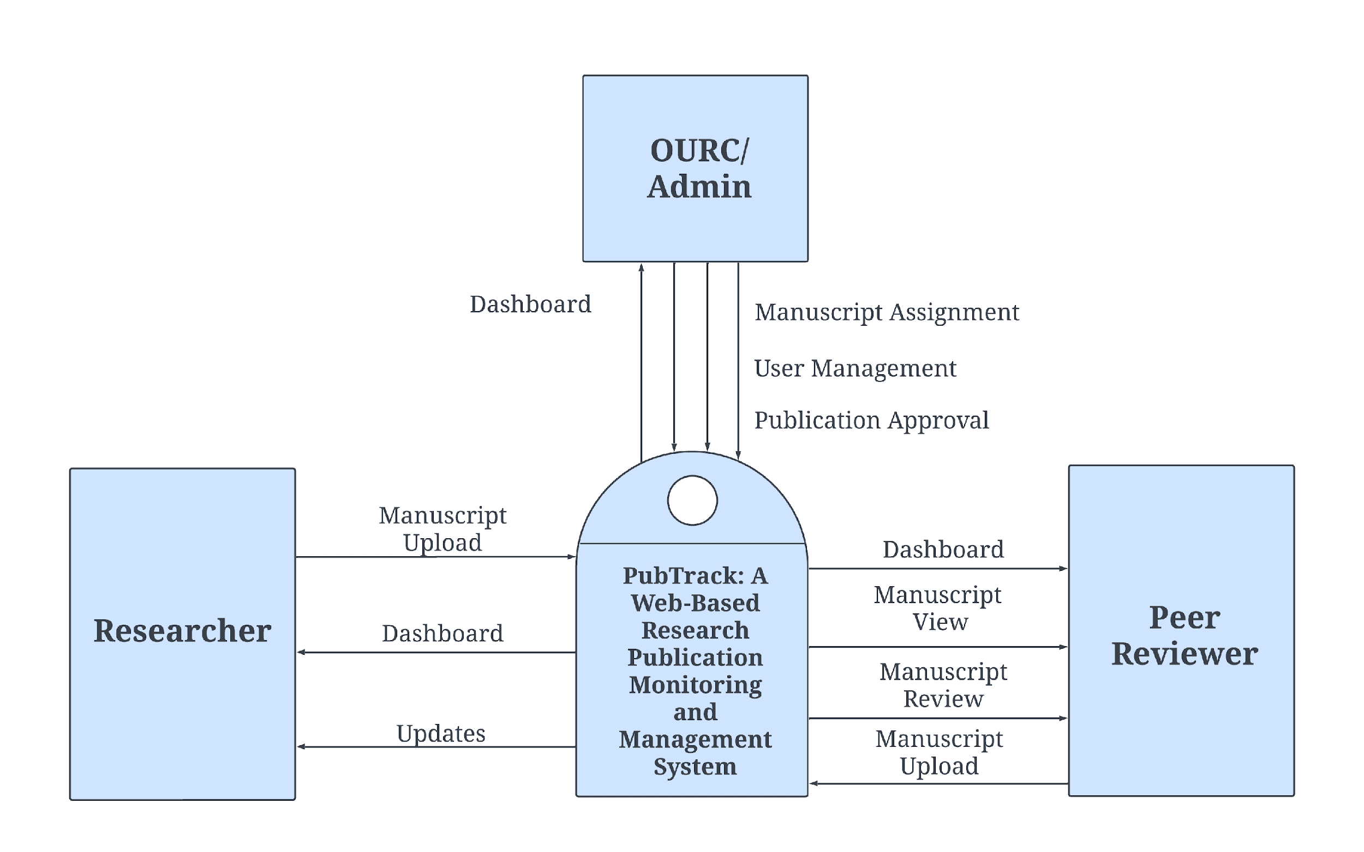

***Figure 10.*** *Context diagram of proposed system*

**Narrative Description**

The figure shows the proposed system process of the project. The researcher applies for publication approval after uploading the manuscript, researcher clicks on dashboard to show where the manuscript is headed. The proposed system receives the manuscripts and passes it to the OURC. The OURC will view the manuscripts and send updates to the researcher whether it is approved or reviewed. The OURC will then submit the manuscript to the Peer Reviewer for manuscript review. The Peer Reviewer will then submit the reviewed manuscript to OURC after reviewing. The OURC will then send back the review to the Researcher. Upon receiving comments, the researcher revises the manuscript accordingly and resubmits it for further consideration.

**Proposed System Process Flow**

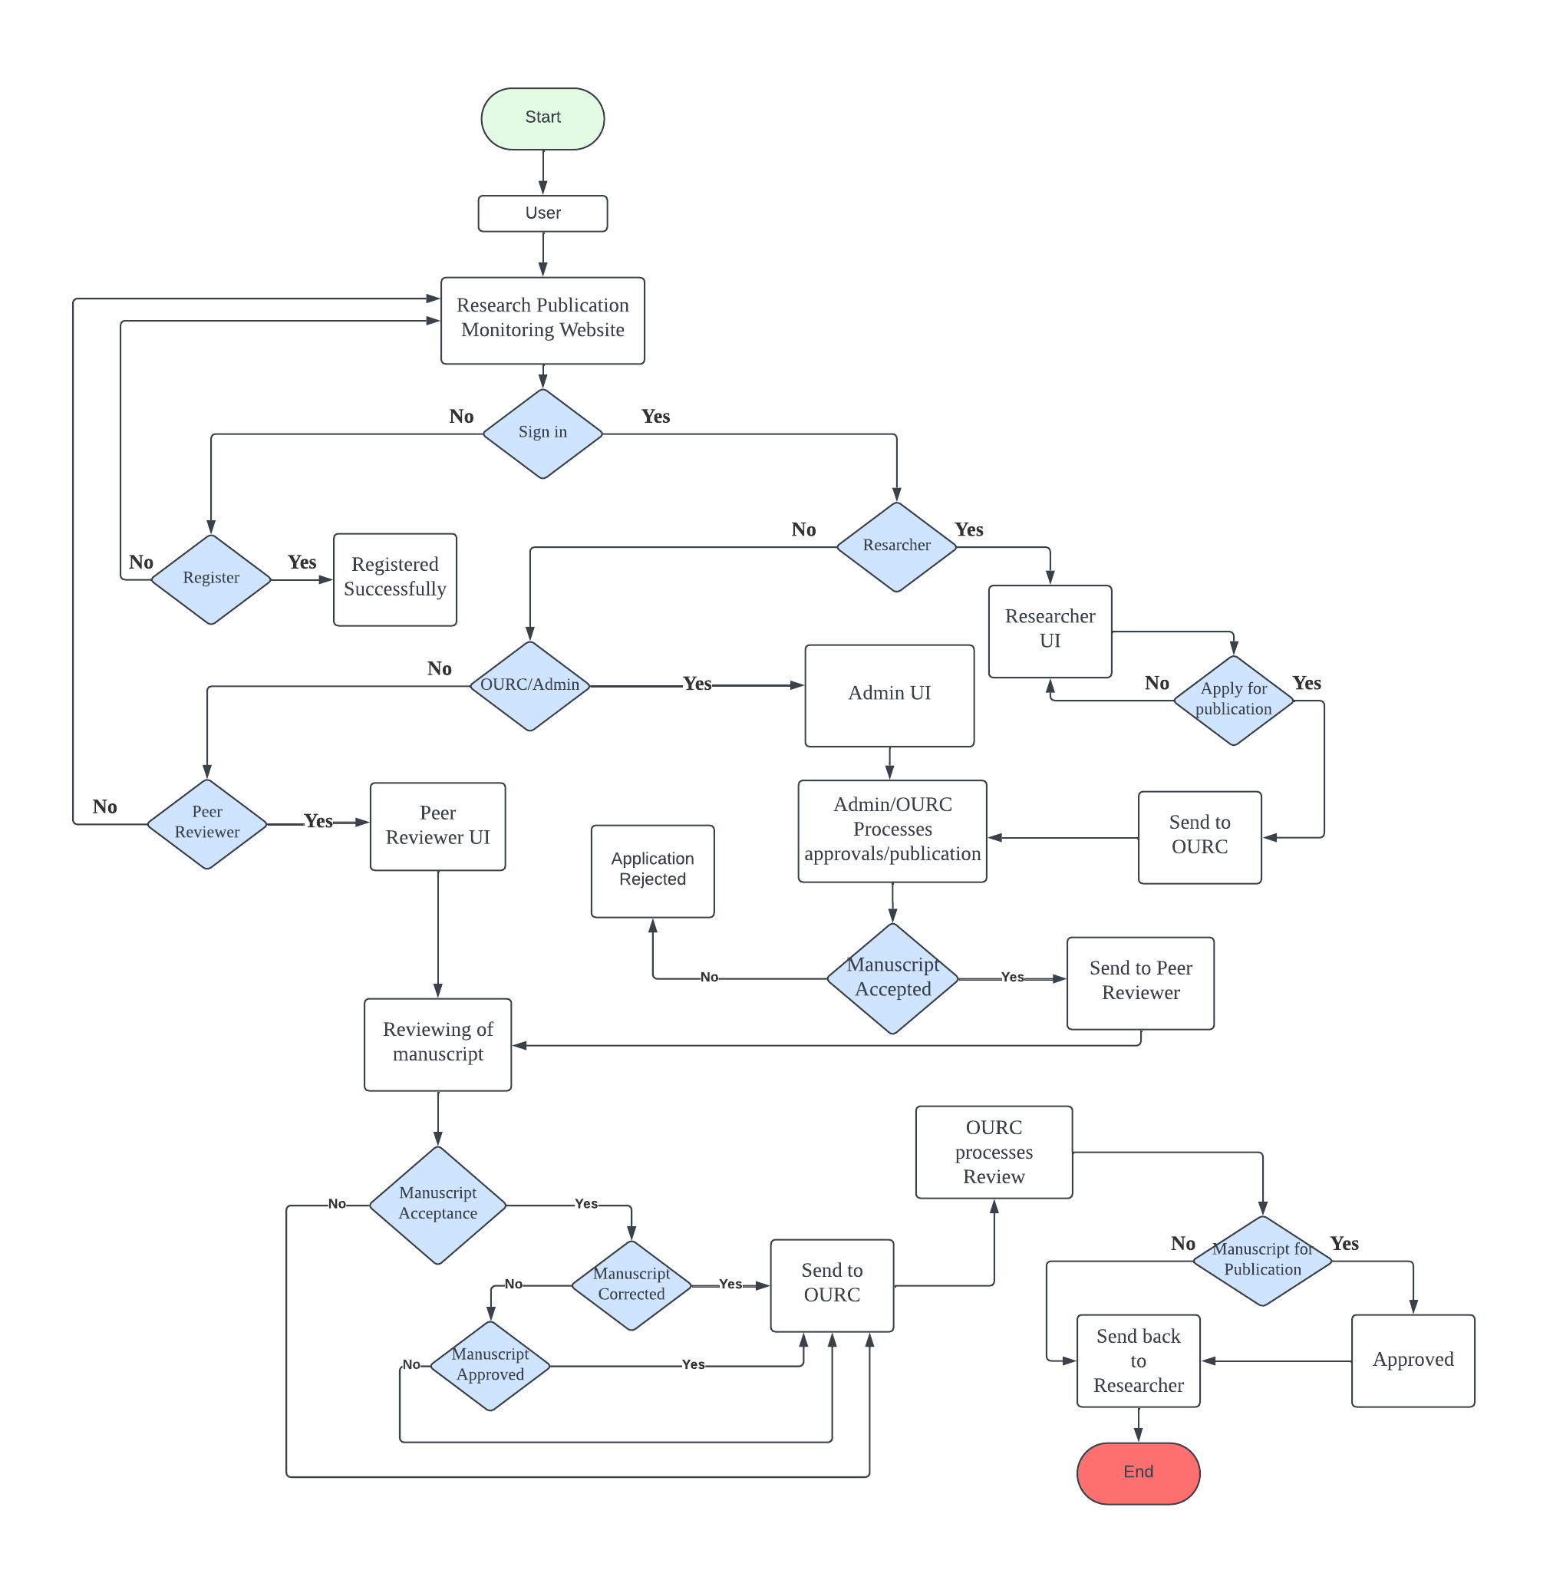

***Figure 11.*** *System process flow of proposed system*

**Entity Relationship Diagram**

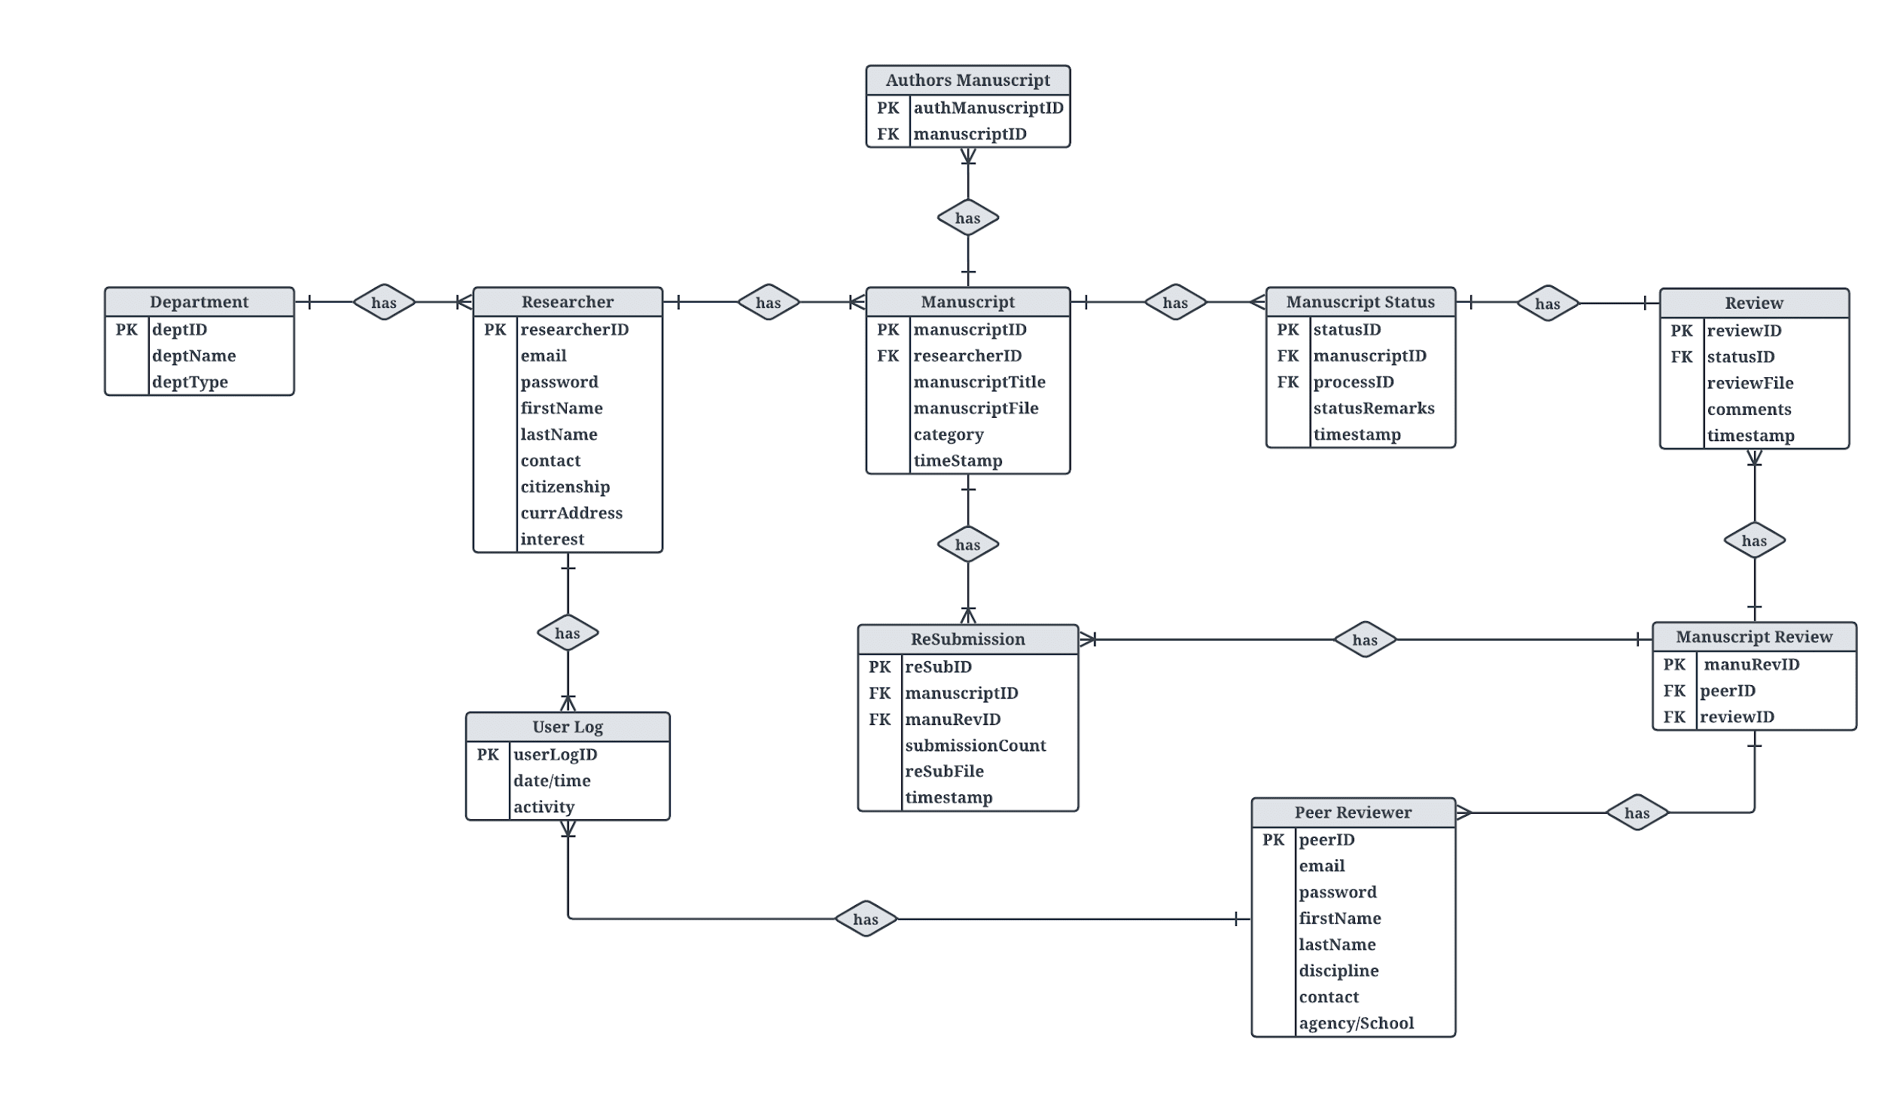

***Figure 12.*** *Entity Relationship Diagram*

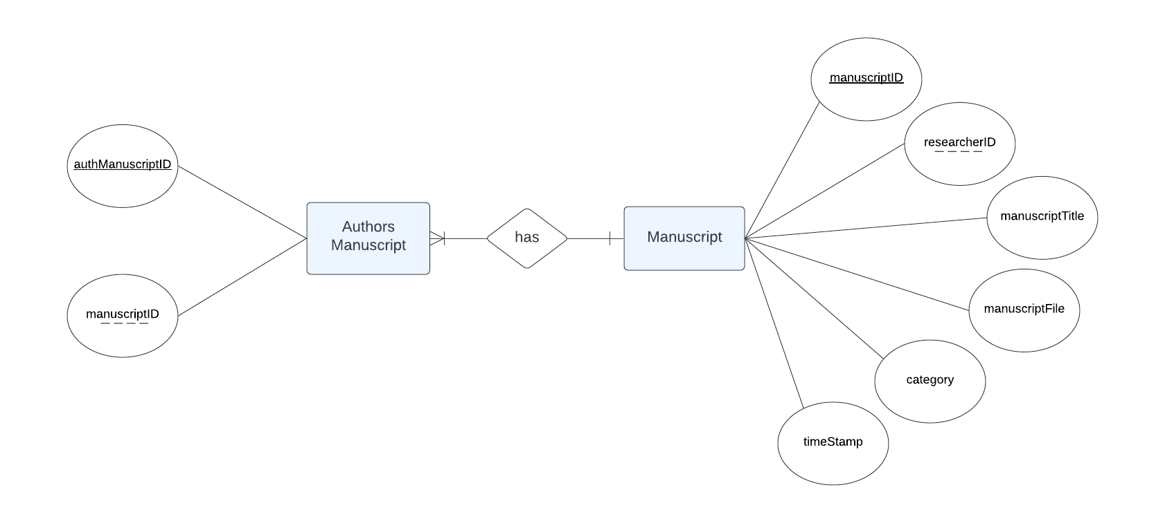

***Figure 13.*** *Authors Manuscript to Manuscript Relationship*

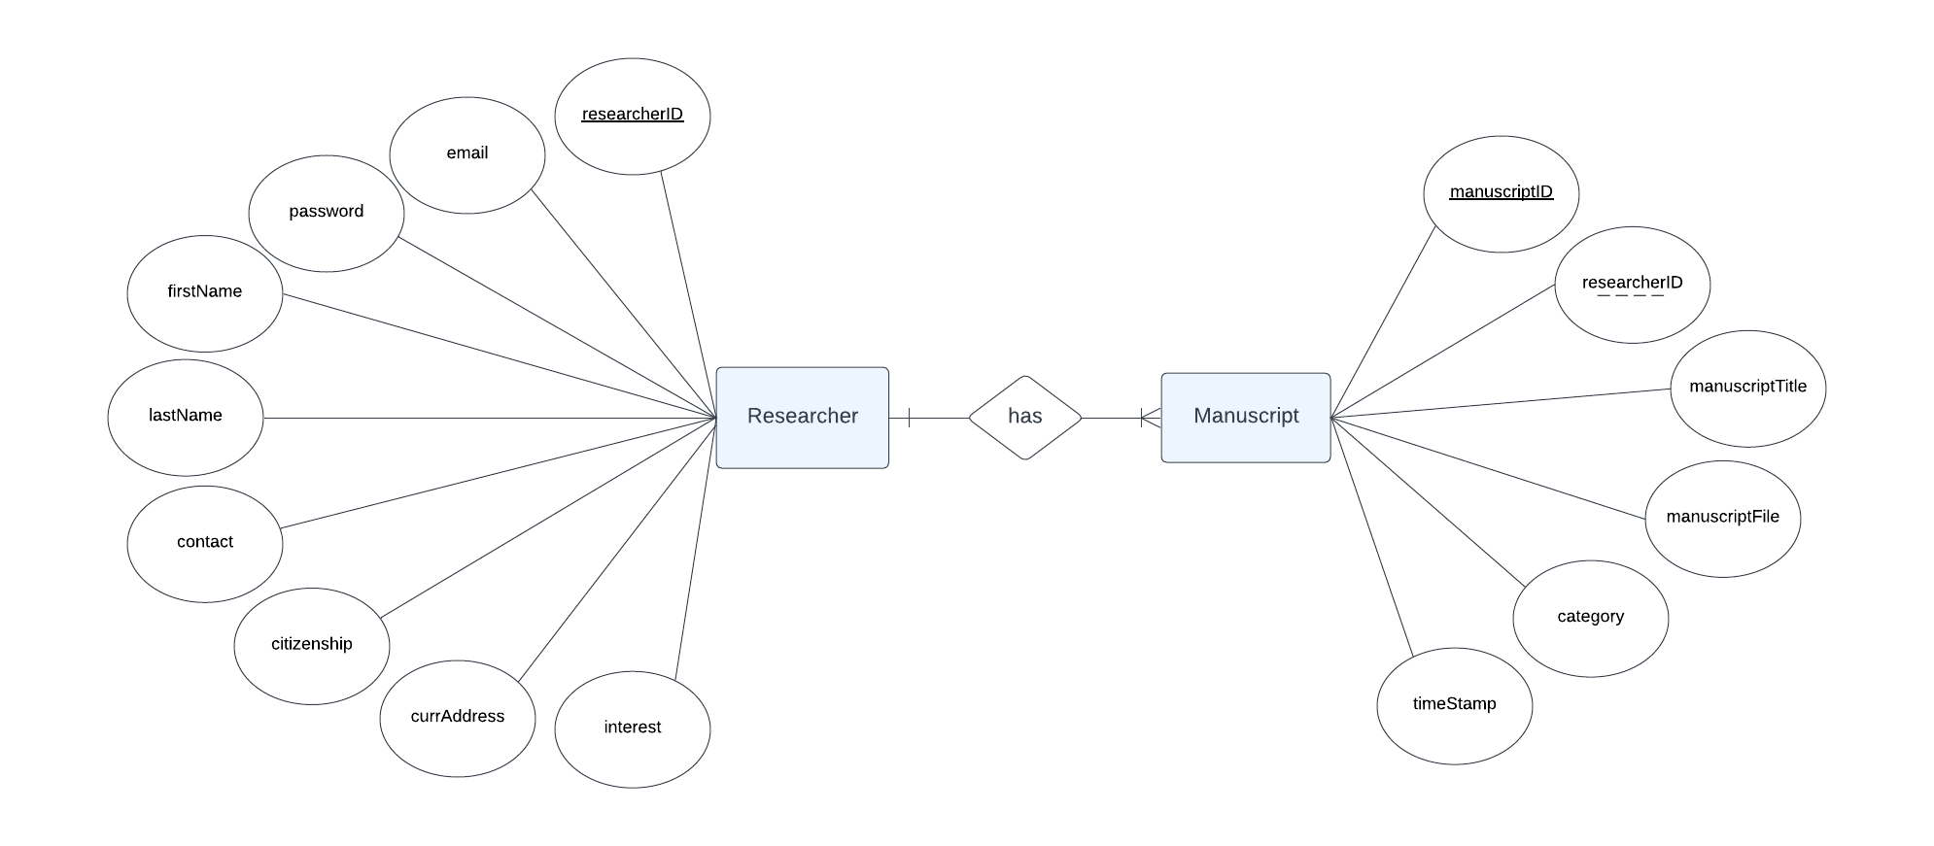

***Figure 14.*** *Researcher to Manuscript Relationship*

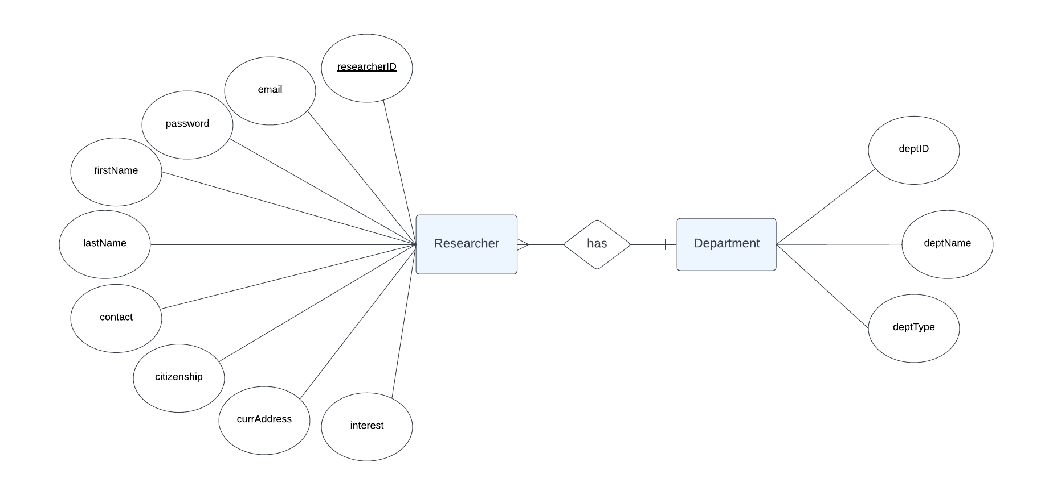

***Figure 15.*** *Researcher to Department Relationship*

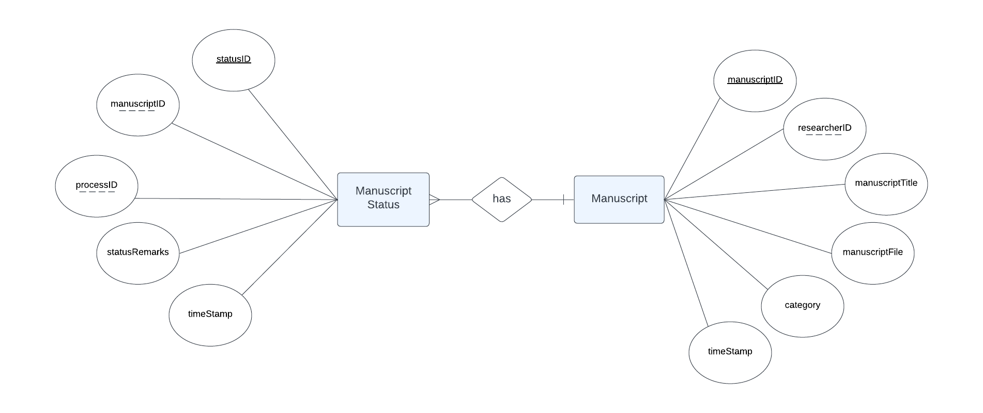

***Figure 16.*** *Manuscript Status to Manuscript Relationship*

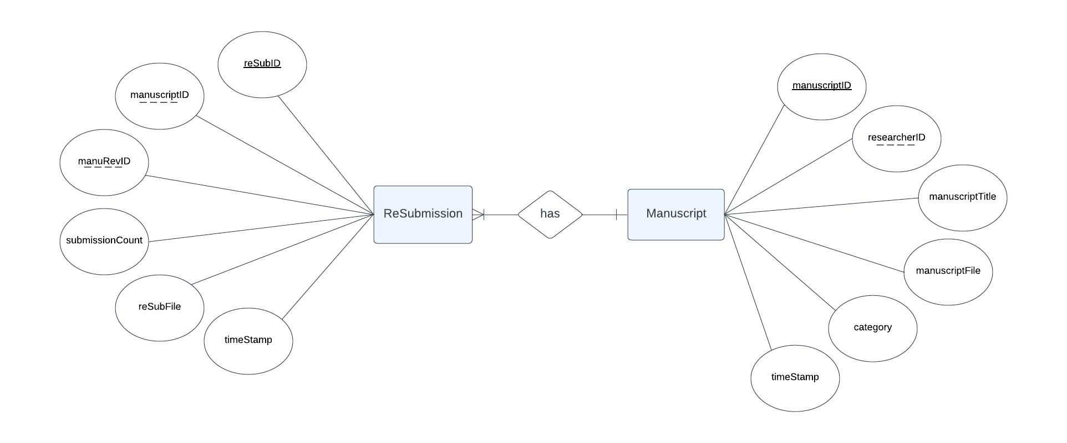

***Figure 17.*** *ReSubmission to Manuscript Relationship*

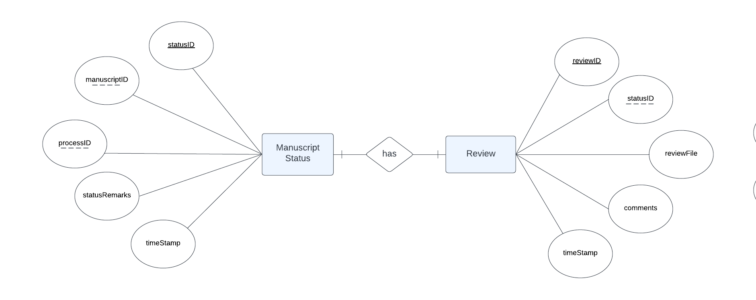

***Figure 18.*** *Manuscript Status to Review Relationship*

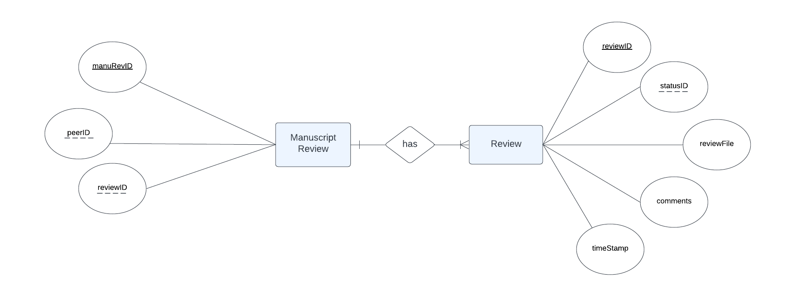

***Figure 19.*** *Manuscript Review to Review Relationship*

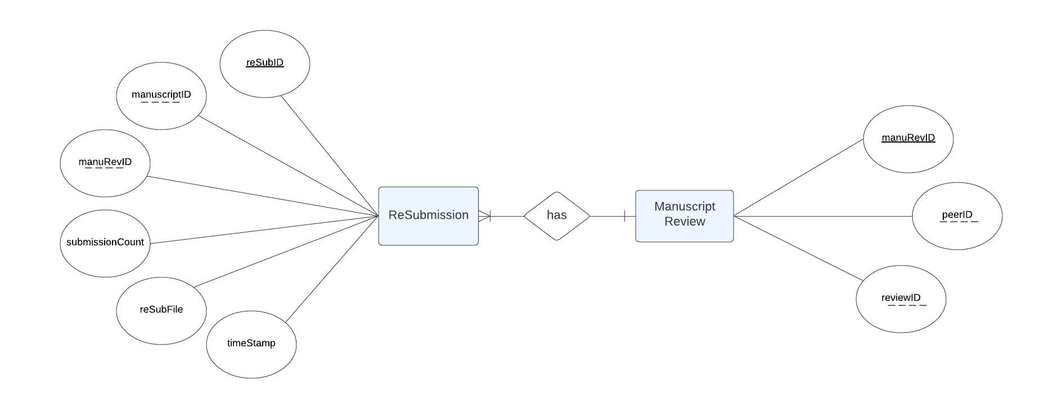

***Figure 20.*** *Resubmission to Manuscript Review Relationship*

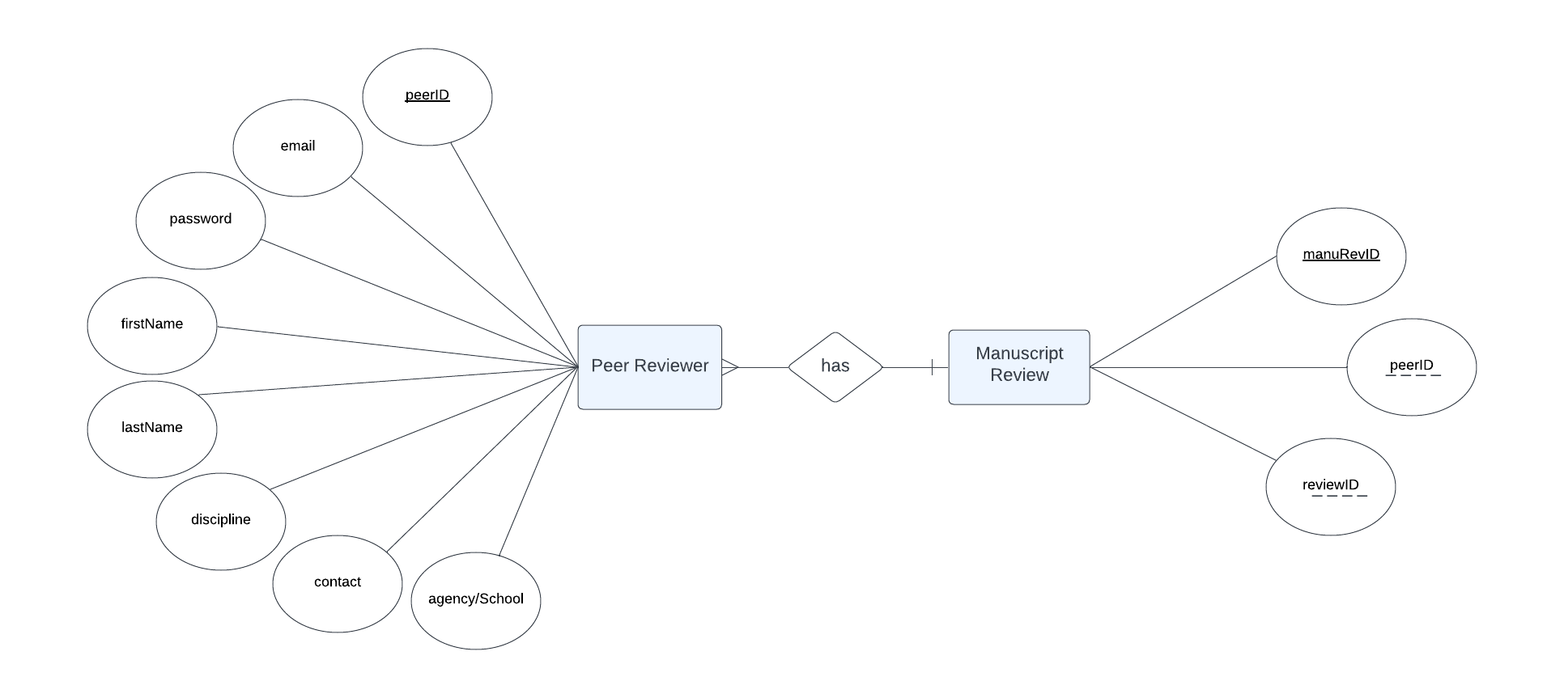

***Figure 21.*** *Peer Reviewer to Manuscript Review Relationship*

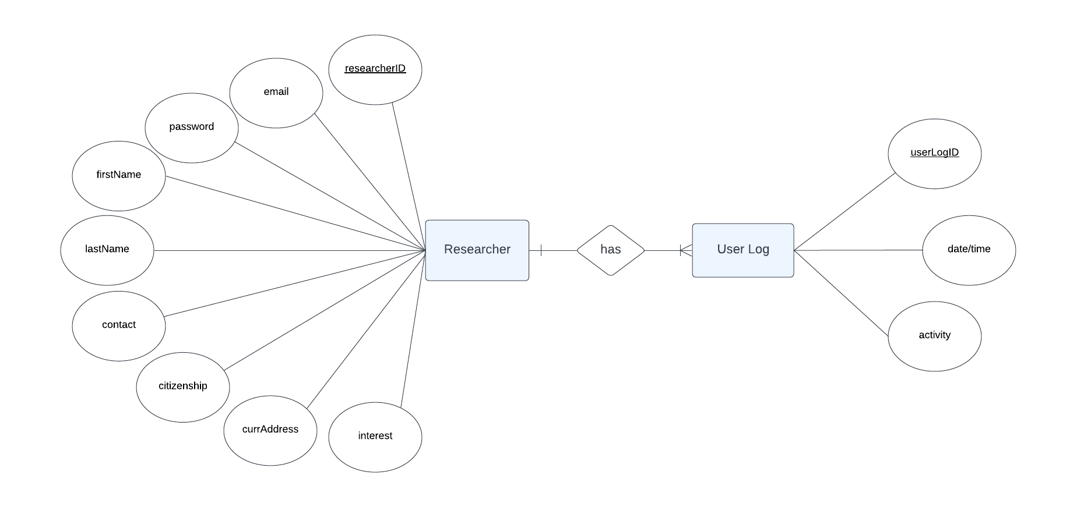

***Figure 22.*** *Researcher to User Log Relationship*

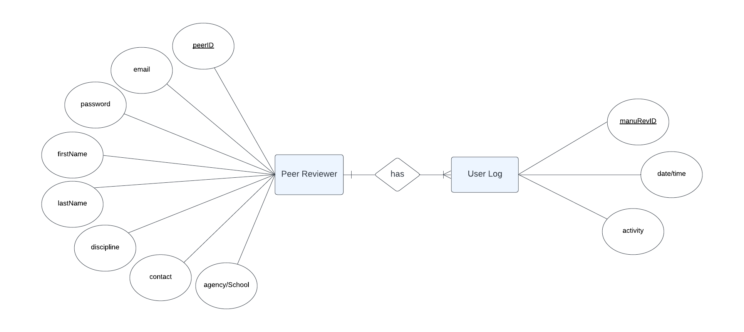

***Figure 23.*** *Peer Reviewer to User Log Relationship*

**Database Structure**

The database structure consists of ten entities, each with its own set of data properties. The name of the database will be Research Publication Monitoring Website Database.

**Table 1. Authors Manuscript** (*This contains Authors Manuscript Information)*

|  |  |  |  |  |
| --- | --- | --- | --- | --- |
| **Field Name** | **Type** | **Size** | **Value** | **Description** |
| authManuscriptID |  |  |  | (PK) Author Manuscript ID |
| manuscriptID |  |  |  | (FK) Manuscript ID |

**Table 2. Manuscript** (*This contains Manuscript Information)*

|  |  |  |  |  |
| --- | --- | --- | --- | --- |
| **Field Name** | **Type** | **Size** | **Value** | **Description** |
| manuscriptID |  |  |  | (PK) Peer ID |
| researcherID |  |  |  | (FK) Researcher ID |
| manuscriptTitle |  |  |  | Manuscript Title |
| manuscriptFile |  |  |  | Manuscript File |
| category |  |  |  | Category |
| timeStamp |  |  |  | Timestamp |

**Table 3. Researcher** (*This contains Researcher Information)*

|  |  |  |  |  |
| --- | --- | --- | --- | --- |
| **Field Name** | **Type** | **Size** | **Value** | **Description** |
| researcherID |  |  |  | (PK) Researcher ID |
| email |  |  |  | Email |
| password |  |  |  | Password |
| firstName |  |  |  | First Name |
| lastName |  |  |  | Last Name |
| contact |  |  |  | Contact Number |
| citizenship |  |  |  | Citizenship |
| currAddress |  |  |  | Current Address |
| interest |  |  |  | Interest |

**Table 4. Department** (*This contains Department Information)*

|  |  |  |  |  |
| --- | --- | --- | --- | --- |
| **Field Name** | **Type** | **Size** | **Value** | **Description** |
| deptID |  |  |  | (PK) Department ID |
| deptName |  |  |  | Department Name |
| deptType |  |  |  | Department Type |

**Table 5. Manuscript Status** (*This contains Manuscript Status Information)*

|  |  |  |  |  |
| --- | --- | --- | --- | --- |
| **Field Name** | **Type** | **Size** | **Value** | **Description** |
| statusID |  |  |  | (PK) Status ID |
| manuscriptID |  |  |  | (FK) Manuscript ID |
| processID |  |  |  | (FK) Process ID |
| statusRemarks |  |  |  | Status Remarks |
| timestamp |  |  |  | Timestamp |

**Table 6. Review** (*This contains Review Information)*

|  |  |  |  |  |
| --- | --- | --- | --- | --- |
| **Field Name** | **Type** | **Size** | **Value** | **Description** |
| reviewID |  |  |  | (PK) Review ID |
| statusID |  |  |  | (FK) Status ID |
| reviewFile |  |  |  | Review File |
| comments |  |  |  | Comments |
| timestamp |  |  |  | Timestamp |

**Table 7. Manuscript Review** (*This contains Manuscript Review Information)*

|  |  |  |  |  |
| --- | --- | --- | --- | --- |
| **Field Name** | **Type** | **Size** | **Value** | **Description** |
| manuRevID |  |  |  | (PK) Manuscript Review ID |
| peerID |  |  |  | (FK) Peer ID |
| reviewID |  |  |  | (FK) ReviewID |

**Table 8. ReSubmission** (*This contains Resubmission Information)*

|  |  |  |  |  |
| --- | --- | --- | --- | --- |
| **Field Name** | **Type** | **Size** | **Value** | **Description** |
| reSubID |  |  |  | (PK) Resubmission ID |
| manuscriptID |  |  |  | (FK) Manuscript ID |
| manuRevID |  |  |  | (FK) Manuscript Review ID |
| submissionCount |  |  |  | Submission Count |
| reSubFile |  |  |  | Resubmission File |
| timestamp |  |  |  | Authors |

**Table 9. Peer Reviewer** (*This contains Submission Count Information)*

|  |  |  |  |  |
| --- | --- | --- | --- | --- |
| **Field Name** | **Type** | **Size** | **Value** | **Description** |
| peerID |  |  |  | (PK) Peer ID |
| email |  |  |  | Email |
| password |  |  |  | Password |
| firstName |  |  |  | First Name |
| lastName |  |  |  | Last Name |
| discipline |  |  |  | Discipline |
| contact |  |  |  | Contact Number |
| agency/School |  |  |  | Timestamp |

**Table 10. User Log** (*This contains User Log Information)*

|  |  |  |  |  |
| --- | --- | --- | --- | --- |
| **Field Name** | **Type** | **Size** | **Value** | **Description** |
| userLogID |  |  |  | (PK) User Log ID |
| date/time |  |  |  | Date/Time |
| activity |  |  |  | Activity |

**Use Case Diagram**

A use case diagram is a dynamic or behavior diagram in UML. Use case diagrams model the functionality of a system using actors and use cases. Use cases are a set of actions, services, and functions that the system needs to perform (SmartDraw, 2019).

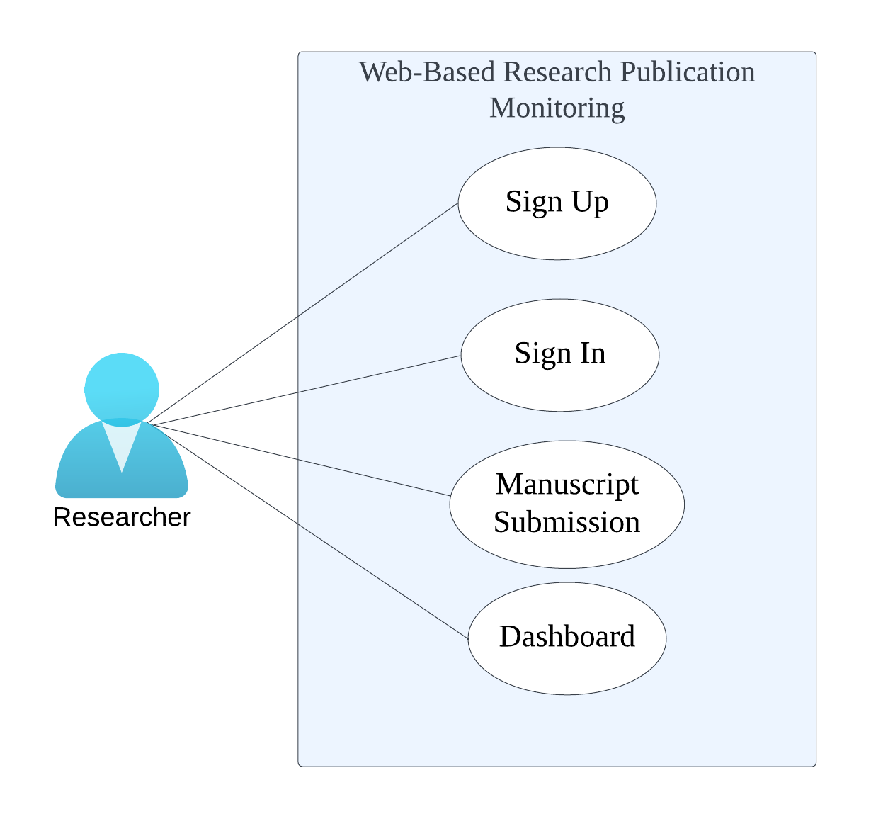

***Figure 25.*** *Use Case Diagram for Researcher*

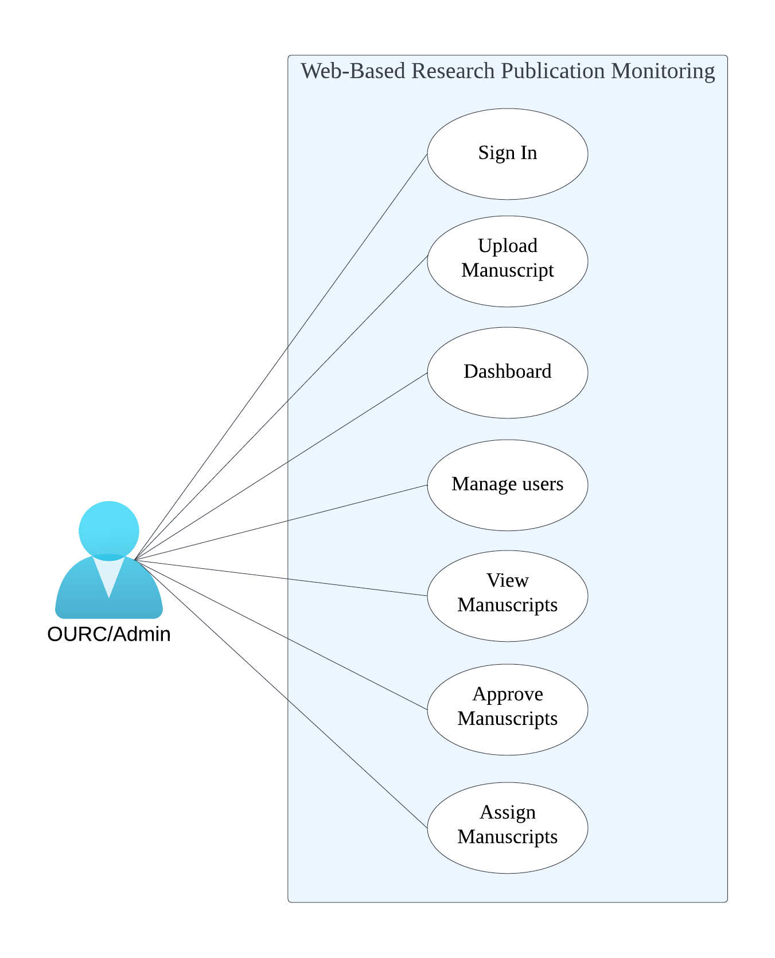

***Figure 26.*** *Use Case Diagram for OURC*

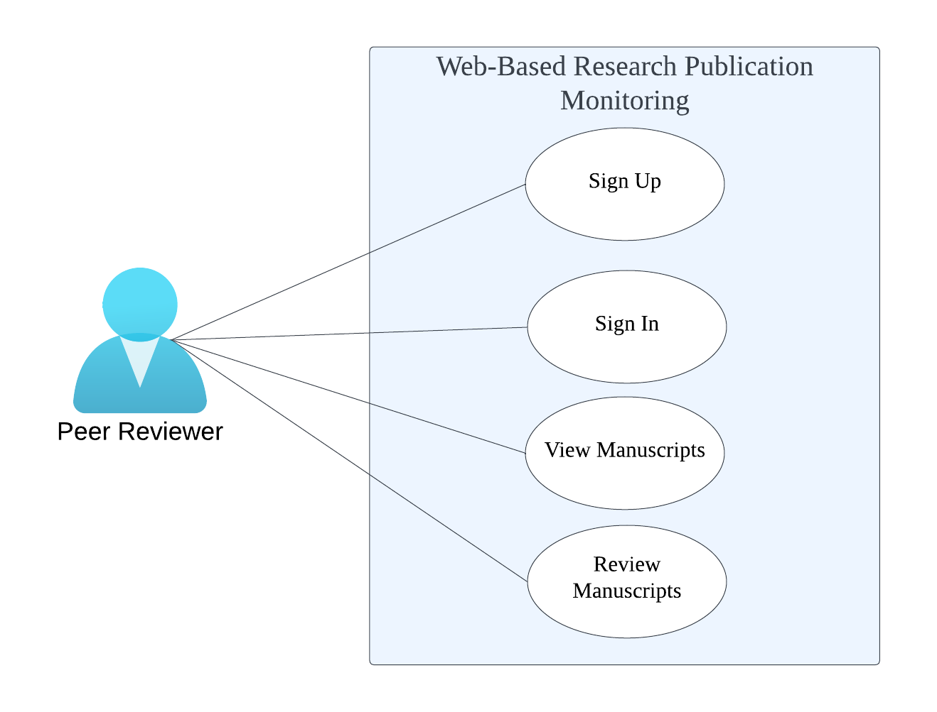

***Figure 27.*** *Use Case Diagram for Peer Reviewer*

**Use Case Description**

A use case description is a text-based narrative of a functionality consisting of detailed, step-by-step interaction between the actor and the system. It describes the outcomes of an action taken to accomplish a specific goal (BusinessAnalysisDoctor, 2019).

|  |  |
| --- | --- |
| **Use Case** | Sign Up |
| **Actors** | Researcher |
| **Description** | This use case demonstrates how researchers register to use the website. |
| **Normal Flow** | 1. Researcher will click Sign Up. 2. Researcher will fill in the required inputs. |
| **Alternative Flow** | If the information required input is not filled out, the missing field will prompt the user for required information. |
| **Pre-condition** | Researcher fills out required information. |
| **Post-condition** | * Researcher is signed up. |
| **Assumption** | Researcher Signs up. |

|  |  |
| --- | --- |
| **Use Case** | Sign In |
| **Actors** | Researcher |
| **Description** | This use case demonstrates how researchers sign in to use the website. |
| **Normal Flow** | 1. Researcher enters their email and password. 2. Researcher will click Sign In. 3. The researcher is now signed in successfully to the website. |
| **Alternative Flow** | If the researcher’s email and password is invalid, the researcher must enter their valid email and password. |
| **Pre-condition** | The researcher must have a registered account. |
| **Post-condition** | * If the researcher's sign in access is denied, the system will give the user an error message. * The researcher has logged in successfully. |
| **Assumption** | Researcher Signs in. |

|  |  |
| --- | --- |
| **Use Case** | Manuscript Submission |
| **Actors** | Researcher |
| **Description** | This use case demonstrates how researchers submit manuscripts on the website. |
| **Normal Flow** | 1. The Researcher fills up and submits the manuscript submission form. |
| **Alternative Flow** | It prompts the user to fill out the Researcher details first. |
| **Pre-condition** | The Researcher must be registered and filled up the Researcher details. |
| **Post-condition** | The researcher has submitted their manuscript for approval. |
| **Assumption** | The Researcher submits a manuscript. |

|  |  |
| --- | --- |
| **Use Case** | Dashboard |
| **Actors** | Researcher |
| **Description** | This use case demonstrates how researchers view the dashboard on the website. |
| **Normal Flow** | 1. Click dashboard 2. View dashboard for pending approvals and reports. |
| **Alternative Flow** | No manuscripts for reports. |
| **Pre-condition** | Must have a submitted manuscript. |
| **Post-condition** | Dashboard is projecting reports and approvals. |
| **Assumption** | There is a manuscript submission. |

|  |  |
| --- | --- |
| **Use Case** | Sign In |
| **Actors** | Administrator |
| **Description** | This use case demonstrates how the administrator signs in to use the website. |
| **Normal Flow** | 1. Administrator enters their email and password 2. Administrator will click Sign In 3. The administrator is now signed in to the website. |
| **Alternative Flow** | If the Admin’s email and password is invalid, the Admin must enter the valid email and password. |
| **Pre-condition** | Created a super admin account. |
| **Post-condition** | * If the Admin’s sign in access is denied, the system will give the user an error message. * The Admin has signed in successfully. |
| **Assumption** | Admin signs in to the website. |

|  |  |
| --- | --- |
| **Use Case** | Manage Users |
| **Actors** | Admin |
| **Description** | This use case demonstrates how the Admin manages users on the website. |
| **Normal Flow** | 1. Click manage users. 2. Delete, update, or view user accounts. |
| **Alternative Flow** | The Manage Users option is not shown on Peer Reviewer and Researcher accounts. |
| **Pre-condition** | Signed in as Admin. |
| **Post-condition** | Admin has configured a user. |
| **Assumption** | Admin manages users. |

|  |  |
| --- | --- |
| **Use Case** | View Manuscripts |
| **Actors** | Administrator |
| **Description** | This use case demonstrates how the administrator views manuscripts on the website. |
| **Normal Flow** | Admin clicks on manuscripts. |
| **Alternative Flow** | There are no manuscripts available. |
| **Pre-condition** | User must be an Admin. |
| **Post-condition** | Admin can see all manuscript submissions from researchers. |
| **Assumption** | The Admin views the manuscript. |

|  |  |
| --- | --- |
| **Use Case** | Approve Manuscripts |
| **Actors** | Admin |
| **Description** | This use case demonstrates how the Admin approves manuscripts on the website. |
| **Normal Flow** | The Admin will approve or reject manuscript submissions. |
| **Alternative Flow** | There are no manuscript submissions. |
| **Pre-condition** | User must be Admin. |
| **Post-condition** | * Manuscript successfully approved. * Manuscript rejected. |
| **Assumption** | Admin Approves a manuscript. |

|  |  |
| --- | --- |
| **Use Case** | Assign Manuscripts |
| **Actors** | Admin |
| **Description** | This use case demonstrates how the Admin assign manuscripts on the website. |
| **Normal Flow** | The Admin will assign manuscript for reviewing to Peer Reviewer/s |
| **Alternative Flow** | There are no manuscript submissions. |
| **Pre-condition** | User must be Admin. |
| **Post-condition** | Manuscript successfully assigned. |
| **Assumption** | Admin assigns a manuscript. |

|  |  |
| --- | --- |
| **Use Case** | Sign Up |
| **Actors** | Peer Reviewer |
| **Description** | This use case demonstrates how peer reviewers signs up to the website. |
| **Normal Flow** | 1. Peer Reviewer clicks on Peer Reviewer Sign Up. 2. Peer Reviewer will fill in the required inputs. |
| **Alternative Flow** | If the information required input is not filled out, the missing field will prompt the user for required information. |
| **Pre-condition** | Peer Reviewer fills out the required inputs. |
| **Post-condition** | * Peer Reviewer is Signed up. |
| **Assumption** | Peer Reviewer Signs Up. |

|  |  |
| --- | --- |
| **Use Case** | Sign In |
| **Actors** | Peer Reviewer |
| **Description** | This use case demonstrates how the peer reviewer signs in to use the website. |
| **Normal Flow** | 1. Peer reviewer enters their email and password. 2. Peer reviewer will click Sign In. 3. The peer reviewer is now signed in successfully to the website. |
| **Alternative Flow** | If the peer reviewer’s email and password is invalid, the peer reviewer must enter the valid email and password. |
| **Pre-condition** | The Peer Reviewer must have a registered account. |
| **Post-condition** | * If the peer reviewer's sign in access is denied, the system will give the user an error message. * The peer reviewer has signed in successfully. |
| **Assumption** | Peer Reviewer signs in to the website. |

|  |  |
| --- | --- |
| **Use Case** | View Manuscripts |
| **Actors** | Peer Reviewer |
| **Description** | This use case demonstrates how the peer reviewer views manuscripts on the website. |
| **Normal Flow** | 1. Click on manuscripts. 2. Pending manuscripts will be shown. |
| **Alternative Flow** | No pending manuscripts. |
| **Pre-condition** | Must be a Peer Reviewer. |
| **Post-condition** | * Peer Reviewers views the manuscript assigned to them. |
| **Assumption** | Peer Reviewer views manuscript. |

|  |  |
| --- | --- |
| **Use Case** | Review Manuscripts |
| **Actors** | Peer Reviewer |
| **Description** | This use case demonstrates how the peer reviewer reviews manuscripts on the website. |
| **Normal Flow** | 1. The Peer Reviewer receives manuscripts from Admin. 2. Begin correcting or reviewing manuscripts. 3. Send to Admin after correcting or reviewing manuscripts. |
| **Alternative Flow** | No manuscript received from Admin. |
| **Pre-condition** | Admin must send researchers manuscripts for review. |
| **Post-condition** | Manuscript is reviewed or approved for publication. |
| **Assumption** | Peer Reviewer reviews manuscripts. |

**Sequence Diagram**

Sequence Diagrams are interaction diagrams that detail how operations are carried out. They capture the interaction between objects in the context of a collaboration. Sequence Diagrams are time focused and they show the order of the interaction visually by using the vertical axis of the diagram to represent time, what messages are sent and when (VisualParadigm, 2019).

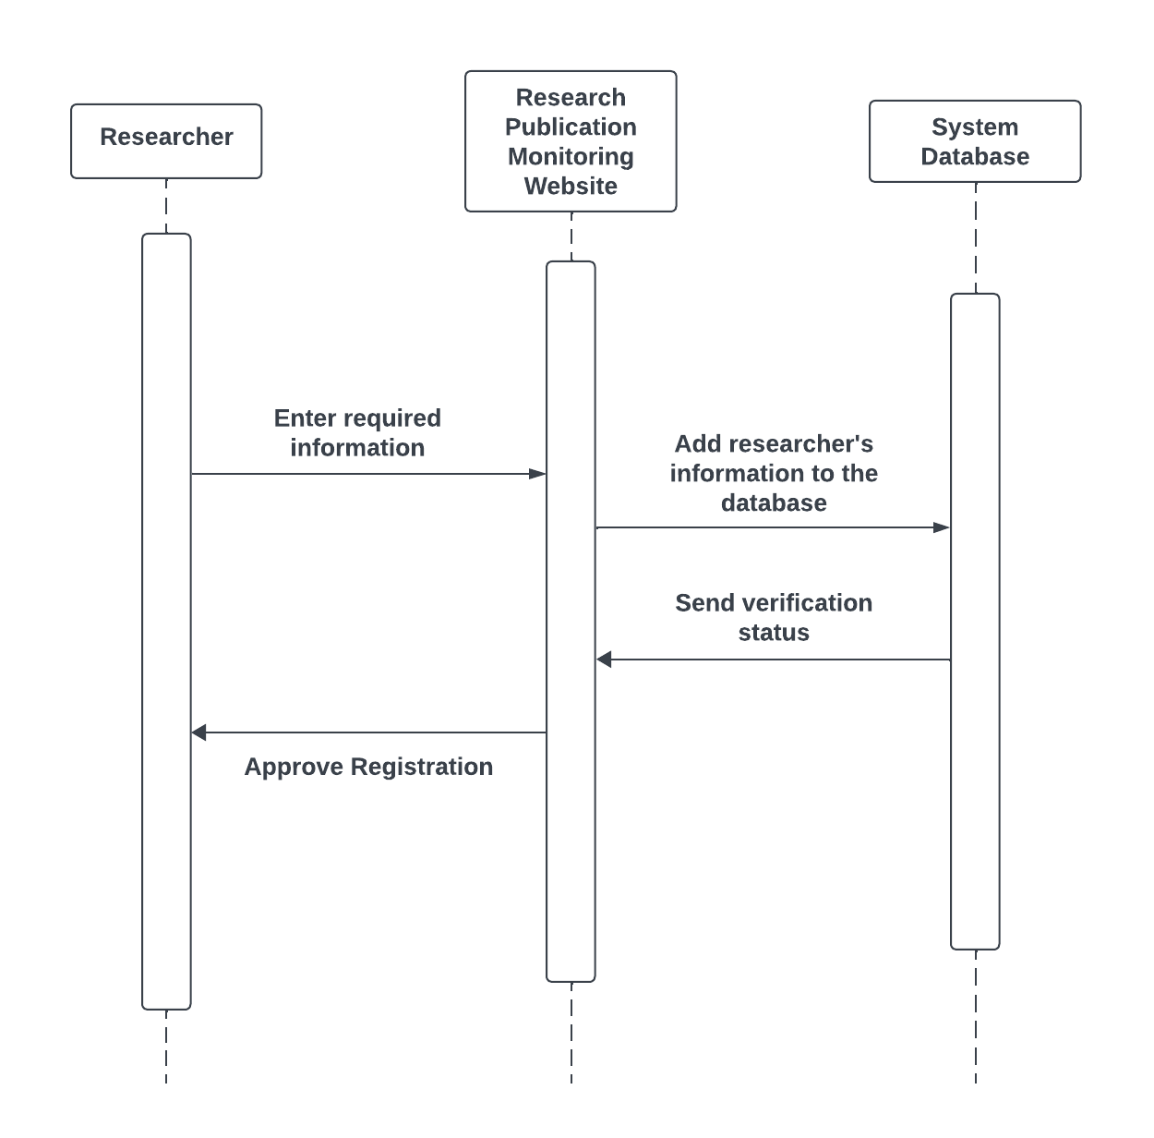

***Figure 28.*** *Sequence Diagram for Register*

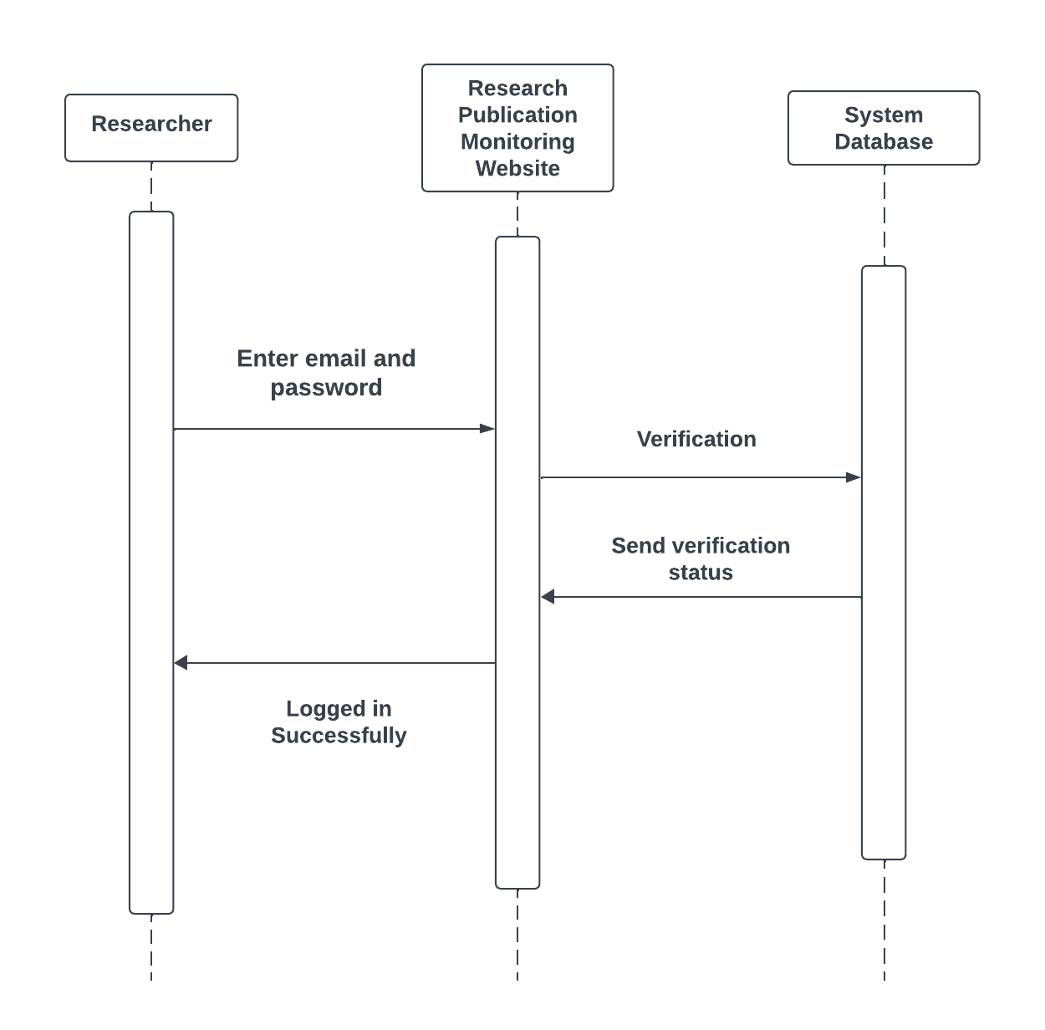

***Figure 29.*** *Sequence Diagram for Login*

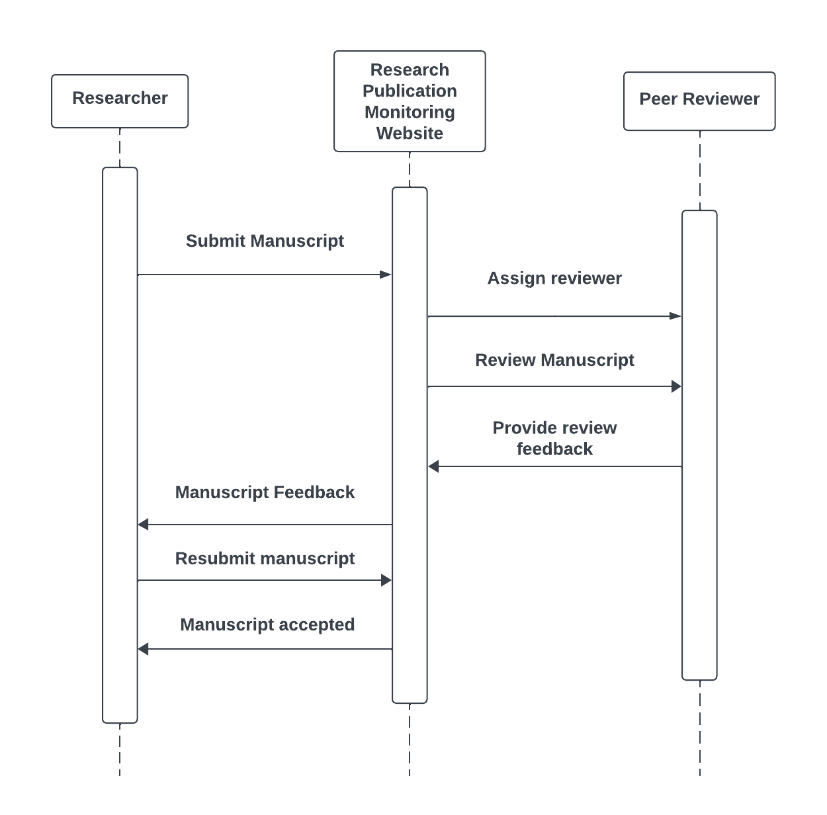

***Figure 30.*** *Sequence Diagram for Upload Manuscript*

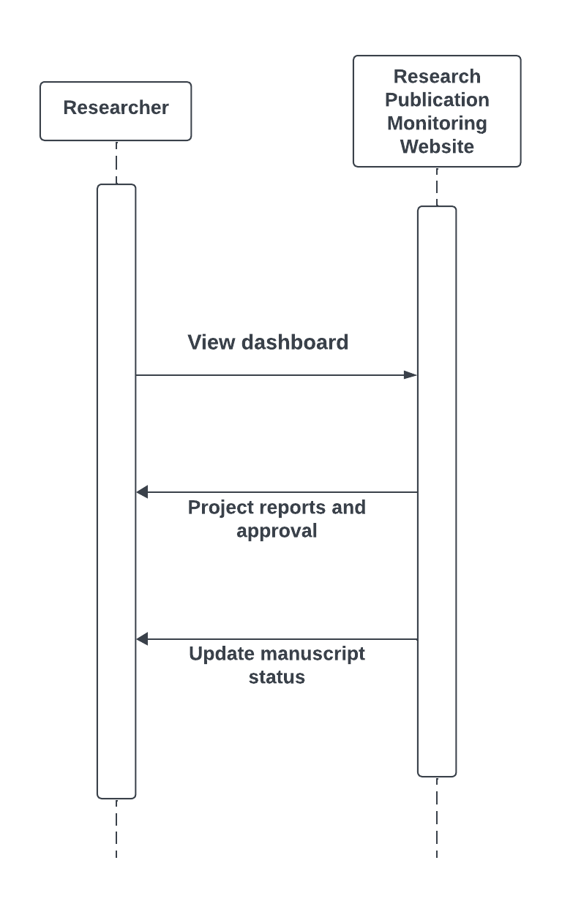

***Figure 31.*** *Sequence Diagram for Dashboard*

**REFERENCES**

Bo, L., Liu, Y., Zhang, Z., Zhu, D., & Wang, Y. (2022). Research on an Online Monitoring System for Efficient and Accurate Monitoring of Mine Water. IEEE Access, 10, 18743–18756. <https://doi.org/10.1109/access.2022.3151244>

Brush, K., & Silverthorne, V. (2022, November). What is Agile Software Development (Agile Methodologies)? TechTarget.<https://www.techtarget.com/searchsoftwarequality/definition/agile-software-development>

Doctor, B. A. (2019, February 19). Use Case Description Basics. Business Analysis Doctor.<https://thebadoc.com/ba-techniques/f/use-case-description-basics>

Feldman, K. (2018). Input-Process-Output (I-P-O) Definition. ISixSigma.<https://www.isixsigma.com/dictionary/input-process-output-i-p-o/>

Granikov, V., Bouthillier, F., & Pluye, P. (2020). Understanding collaboration in monitoring research publications: Protocol for a qualitative multiple case study. Education for Information, 36(1), 69–79. <https://doi.org/10.3233/efi-190340>

Kelly, J., Sadeghieh, T., & Adeli, K. (2014). Peer Review in Scientific Publications: Benefits, Critiques, & a Survival Guide. The Journal of the International Federation of Clinical Chemistry and Laboratory Medicine, 25(3), 227–243. NCBI.<https://www.ncbi.nlm.nih.gov/pmc/articles/PMC4975196/>

Kogure, S., Nakamura, R., Makino, K., Yamashita, K., Konishi, T., & Itoh, Y. (2015). Monitoring system for the effective instruction based on the semi-automatic evaluation of programs during programming classroom lectures. Research and Practice in Technology Enhanced Learning, 10(1). <https://doi.org/10.1186/s41039-015-0019-8>

MacCuspie, R. I., Hyman, H., Yakymyshyn, C., Srinivasan, S. S., Dhau, J., & Drake, C. (2014). A framework for identifying performance targets for sustainable nanomaterials. Sustainable Materials and Technologies, 1-2, 17–25.<https://doi.org/10.1016/j.susmat.2014.11.003>

Monitoring System - an overview | ScienceDirect Topics. (n.d.). Www.sciencedirect.com. Retrieved July 2, 2024, from <https://www.sciencedirect.com/topics/engineering/monitoring-system>

Peer review in research: Navigating its role in quality and integrity. (2024, February 21). Www.turnitin.com.<https://www.turnitin.com/blog/peer-review-in-research-navigating-its-role-in-quality-and-integrity>

Pontis, S., Blandford, A., Greifeneder, E., Attalla, H., & Neal, D. (2015). Keeping up to date: An academic researcher’s information journey. Journal of the Association for Information Science and Technology, 68(1), 22–35.<https://doi.org/10.1002/asi.23623>

Reed, M. S., Ferré, M., Martin-Ortega, J., Blanche, R., Lawford-Rolfe, R., Dallimer, M., & Holden, J. (2021). Evaluating impact from research: A methodological framework. Research Policy, 50(4), 104147. Sciencedirect.<https://doi.org/10.1016/j.respol.2020.104147>

Ross-Hellauer, T. (2017). What is open peer review? A systematic review. F1000Research, 6(588), 588.<https://doi.org/10.12688/f1000research.11369.2>

Sandström, U., & van den Besselaar, P. (2016). Quantity and/or Quality? The Importance of Publishing Many Papers. PLOS ONE, 11(11), e0166149.<https://doi.org/10.1371/journal.pone.0166149>

smartdraw. (2019). Use Case Diagrams - Use Case Diagrams Online, Examples, and Tools. Smartdraw.com.<https://www.smartdraw.com/use-case-diagram/>

Varajão, J., Lourenço, J. C., & Gomes, J. (2022). Models and methods for information systems project success evaluation – A review and directions for research. Heliyon, 8(12), e11977.<https://doi.org/10.1016/j.heliyon.2022.e11977>

Visual Paradigm. (2019). What is Sequence Diagram? Visual-Paradigm.com.<https://www.visual-paradigm.com/guide/uml-unified-modeling-language/what-is-sequence-diagram/>

‌

‌

‌

‌

‌

‌

‌